BC 4302 / BC3002

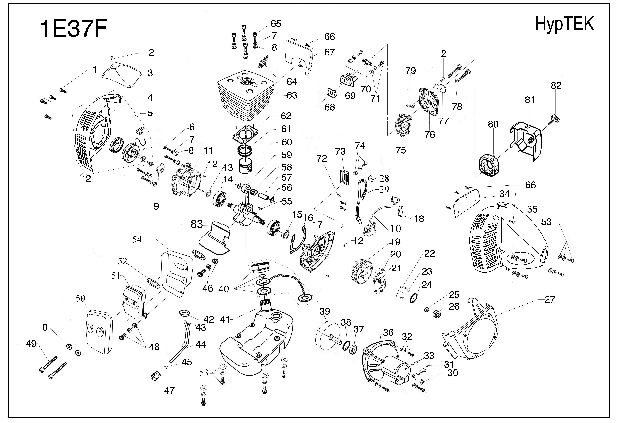
FIG | REFERENCIA | DESCRIPCION | QTY |  | FIG | REFERENCIA | DESCRIPCION | QTY
01 | 3510 001 06180 | Hex screw M6x18 | 4 |  | 43 | 3405 000 03470 | Outlet pipe | 0
02 | 3503 003 04110 | Screw ST4.2x9.5 | 3 |  | 44 | 3405 000 03460 | Inlet pipe | 0
03 | 3201 002 30030 | Spark plug cover | 1 |  | 45 | 3506 001 04000 | Washer ￠4 | 1
04 | 3201 002 30220 | Starter housing | 1 |  | 46 | 3503 000 00630 | Screw set M5x16 | 1
05 | 3407 005 30120 | Starter housing assy | 1 |  | 47 | 1206 008 03410 | Fuel filter | 1
06 | 3510 000 05300 | Hex screw M5x30 | 4 |  | 48 | 3503 000 00620 | Screw set M5x12 | 1
07 | 3506 000 00730 | Spring washer ￠5 | 8 |  | 49 | 3510 000 00570 | Hex screw M5x65 | 2
08 | 3506 000 00720 | Washer ￠5 | 10 |  | 50 | 3202 000 03020 | Muffler cover | 1
09 | 3399 000 03410 | Start pulley | 1 |  | 51 | 1205 008 03010 | Muffler | 1
10 | 1201 002 30020 | Ignition Coil | 1 |  | 52 | 3701 005 30100 | Muffler gasket | 2
11 | 3003 000 03410 | Rear crank case | 1 |  | 53 | 3503 000 00650 | Screw set M5x20 | 8
12 | 3507 000 00770 | Position pin ￠3x10 | 5 |  | 54 | 3202 000 03010 | Muffler housing | 1
13 | 3502 000 00520 | Oil seal 12x22x7 | 1 |  | 55 | 3508 000 00790 | Woodruff Key 10x3 | 1
14 | 3501 000 00010 | Ball bearing 6201 | 2 |  | 56 | 3506 000 02610 | Piston pin clip ￠8 | 2
15 | 3502 000 00530 | Oil seal 12x32x8 | 1 |  | 57 | 3507 000 30100 | Piston pin ￠8x30 | 1
16 | 3701 005 00840 | Crankcase gasket | 1 |  | 58 | 3501 000 02620 | Ball bearing K8-11-11 | 1
17 | 3002 000 03410 | Front crank case | 1 |  | 59 | 3301 006 03010 | crank shaft | 1
18 | 3406 000 03020 | Cable jacket | 1 |  | 60 | 3302 000 03010 | Piston | 1
19 | 1201 002 34012 | Fly wheel | 1 |  | 61 | 3303 000 03010 | Piston ring | 2
20 | 3304 003 03410 | Clutch shoe | 2 |  | 62 | 3701 005 00850 | Cylinder gasket | 1
21 | 3316 000 03430 | Spring | 1 |  | 63 | 3001 000 03010 | Cylinder | 1
22 | 3506 000 00740 | Spring washer ￠10 | 2 |  | 64 | 1204 008 00040 | Spark plug | 1
23 | 3503 000 00540 | Clutch screw M8 | 2 |  | 65 | 3510 000 05200 | Hex screw M5x20 | 4
24 | 3506 000 03410 | Stop ring ￠32 | 1 |  | 66 | 3503 003 04130 | Screw St4.2x13 | 7
25 | 3506 000 00750 | Spring washer ￠8 | 1 |  | 67 | 3201 002 30010 | Air guide | 1
26 | 3505 000 00690 | Nut M8x1 | 1 |  | 68 | 3701 005 00820 | Inlet gasket | 1
27 | 3004 000 03010 | Fly wheel cover | 1 |  | 69 | 3402 010 34200 | Heat insulator | 1
28 | 3406 000 03010 | Cable jacket | 1 |  | 70 | 3701 005 00830 | Carburetor gasket | 1
29 | 3702 005 00870 | Switch cable | 1 |  | 71 | 3503 000 00700 | Screw set M5x22 | 2
30 | 3506 000 01510 | Stop ring ￠15 | 1 |  | 72 | 3503 000 00710 | Screw set M4x18 | 2
31 | 3510 002 06280 | Hex screw set M6x28 | 1 |  | 73 | 3399 000 03420 | Fan shield | 1
32 | 3510 003 06200 | Hex screw set M6x20 | 4 |  | 74 | 3503 000 00610 | Screw set M5x10 | 1
33 | 3510 000 05120 | Hex screw M5x12 | 1 |  | 75 | 1203 008 03010 | Carburetor | 1
34 | 3201 002 30020 | Housing connector | 1 |  | 76 | 3401 000 03430 | Air filter assy | 1
35 | 3201 002 30120 | Front housing | 1 |  | 77 | 3401 000 03420 | Chock door | 1
36 | 3305 003 34350 | Clutch seat | 1 |  | 78 | 3503 000 00670 | Screw set M5x50 | 2
37 | 3501 003 62020 | Ball bearing 6202-2Z | 1 |  | 79 | 3401 000 03410 | Chock lever | 1
38 | 3506 000 03420 | Stop ring ￠35 | 1 |  | 80 | 3499 000 03410 | Air filter | 1
39 | 3305 000 81540 | Clutch drum | 1 |  | 81 | 3203 000 03020 | Air filter cover | 1
40 | 3403 005 30100 | Tank cap | 1 |  | 82 | 3503 000 00560 | Screw | 1
41 | 3404 005 03410 | Fuel tank | 1 |  | 83 | 3499 000 03420 | Heat insulator | 1
42 | 3406 000 03430 | Pipe jacket | 1

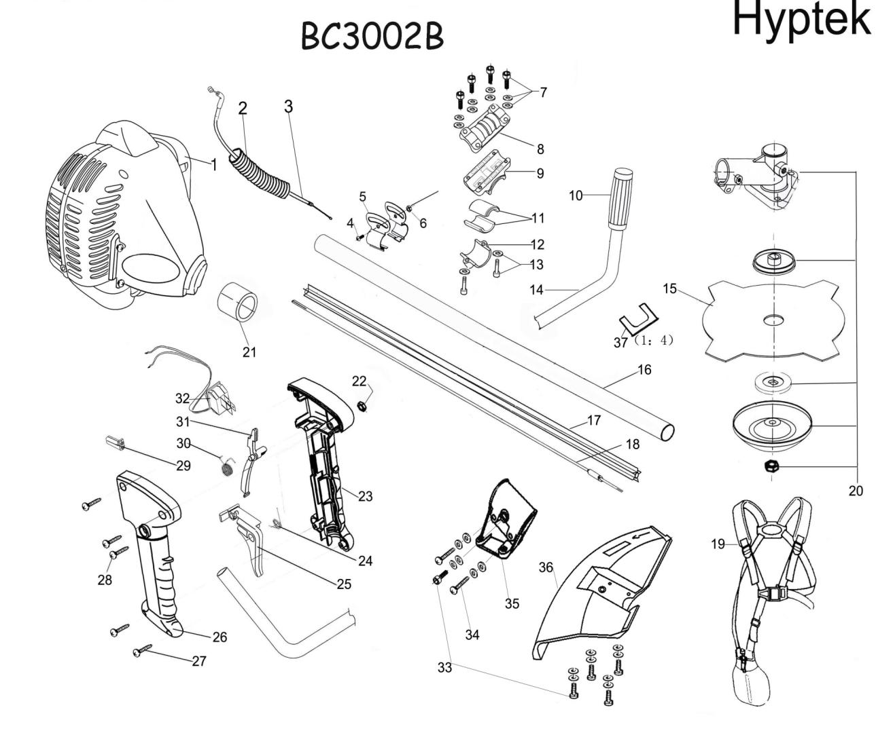
FIG | REFERENCIA | DESCRIPCION | QTY
01 | 8001 030 23200 | N.A | 1
02 | 3411 002 03350 | Ripple tube | 1
03 | 3704 002 11350 | Accelerator cable | 1
04 | 3503 001 06100 | Screw M6x10 | 1
05 | 3322 003 10350 | Belt pothook | 2
06 | 3505 001 06000 | Nut M6 | 1
07 | 3510 003 05250 | Hex screw set M5x25 | 4
08 | 3325 003 10210 | Upper bracket | 1
09 | 3325 003 10220 | Mid bracket | 1
10 | 3406 003 13340 | Rubber handle | 1
11 | 3406 002 25480 | Rubber plate | 2
12 | 3325 003 10230 | Lower bracket | 1
13 | 3510 002 06280 | Hex screw set M6x28 | 2
14 | 3320 003 20840 | Handle U pipe | 1
15 | 3322 003 04320 | 4T blade | 1
16 | 3320 002 14880 | Staight pipe | 1
17 | 3411 002 14410 | Nylon pipe | 1
18 | 3320 002 14950 | Flexiable shaft | 1
19 | 3803 002 02350 | Double belt | 1
20 | 3323 003 61340 | Gear case assy | 1
21 | 3406 002 63260 | Rubber bush | 1
22 | 3505 001 05000 | Nut M5 | 1
23 | 3413 006 20340 | Handle left | 1
24 | 3316 003 11340 | Spring | 1
25 | 3413 006 23342 | Accelerator trigger | 1
26 | 3413 006 21340 | Handle right | 1
27 | 3503 003 04130 | Screw St4.2x13 | 4
28 | 3503 001 05320 | Screw M5x32 | 1
29 | 3413 006 24342 | Position pin | 1
30 | 3316 003 21340 | Spring | 1
31 | 3413 006 22342 | Safety lever | 1
32 | 3706 001 10620 | Switch A-1 | 1
33 | 3510 003 05160 | Hex screw set M5x16 | 5
34 | 3503 000 00660 | Screw set M5x25 | 2
35 | 3211 004 20362 | Blade guard seat | 1
36 | 3211 004 20360 | Blade guard | 1
37 | 3406 002 10400 | 4T Blade jacket | 4
 | 8011 001 00070 | N.A | 1

BC4302 Exploded view & Spare parts--Trimmer Kit

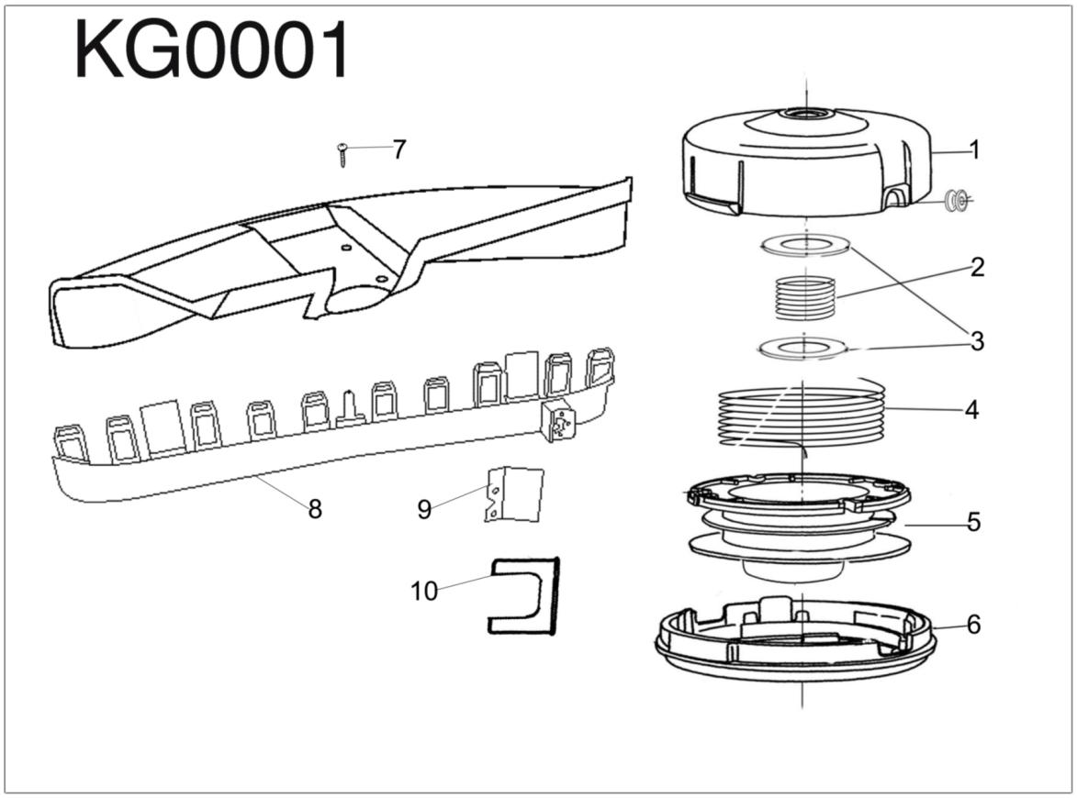

FIG | REFERENCIA | DESCRIPCION | QTY | NOTA
01 | 3408 005 11340 | Spool body | 1 | Spool Assy
02 | 3316 005 10340 | Spring | 1 | Spool Assy
03 | 3408 005 16340 | Spring washer | 2 | Spool Assy
04 | 3704 000 01340 | Nylon line | 1 | Spool Assy
05 | 3408 005 13340 | Spool wheel | 1 | Spool Assy
06 | 3408 005 12340 | Spool cover | 1 | Spool Assy
07 | 3503 003 04130 | Screw St4.2x13 | 1
08 | 3211 004 20361 | Blade guard regula | 1
09 | 3322 002 15350 | Nylon cut | 1
10 | 3406 002 10300 | 3T Blade jacket | 1

